Area questions- You should aim to understand these!!!!!!!
1.
2. | 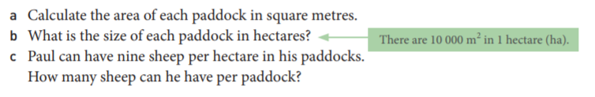
3. | 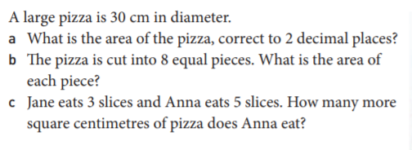

Area questions- You should aim to understand these!!!!!!!
1.
2. | 
3. | 

ANSWERS:
1.
2. | 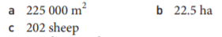
3. | 